Combining advanced text-mining algorithms with mass spectrometry fragmentation data for substructure exploration in untargeted metabolomics data

**Justin J.J. van der Hooft1*, Joe Wandy2, Michael P. Barrett1, Karl V. Burgess1, Simon Rogers1,2\***

1 Glasgow Polyomics, University of Glasgow, Glasgow, United Kingdom

2 School of Computing Science, University of Glasgow, Glasgow, United Kingdom

**\*Correspondence:** Justin J.J. van der Hooft, Glasgow Polyomics, Level 2, Room 235, Wolfson Wohl Cancer Research Centre, Garscube Estate, Glasgow, G61 1HQ, United Kingdom.

justin.vanderhooft@glasgow.ac.uk

**\*Correspondence:** Simon Rogers, Room S123, School of Computing Science, Sir Alwyn Williams Building, Glasgow, G12 8QQ, United Kingdom.

Simon.Rogers@glasgow.ac.uk

Keywords: Data mining, Metabolomics, Mass Spectrometry, high-resolution, fragmentation, Latent Dirichlet Allocation, visualization, software, text-mining, pattern recognition.

**Abstract**

Adaptation of algorithms capable of pulling knowledge from different types of structured complex data across disparate data-types has great potential. In the burgeoning field of untargeted metabolomics, metabolite annotation, classification, and identification remain arduous and problematic processes. High-resolution mass spectrometry fragmentation improves the structural elucidation process. However, given the enormous number of spectra typically generated, it is a daunting task to extract relevant structural information from all acquired fragmentation patterns. Effective data reduction is required. In this paper, we propose a novel unsupervised approach that reduces the large number of fragmentation spectra to concurring patterns of mass fragments or neutral losses to which precursor ions are associated. The approach is based on Latent Dirichlet Allocation (LDA), a technique widely used for modelling text documents. We have adapted LDA to handle MS2 spectral information and we call the resulting workflow ‘MS2LDA’. Structural annotation of resulting concurring patterns, which we call ‘Mass2Motifs’, resulted in the structural annotation of relevant biochemical substructures or structural features in four complex mixtures. Our results demonstrate that the proposed approach can extract structural features in the form of sets of mass fragments and neutral losses in an unsupervised manner without any *a-priori* knowledge. This is not something that can be done with any of the current metabolomics analysis tools. We conclude that the resulting workflow allows a researcher to focus on relevant fragmentation patterns in data-dependent mass spectrometry fragmentation files and use them as aid in metabolite annotation and classification.

**1.0 Introduction**

Ever increasing quantities of data are becoming available, from which useful knowledge can be gleaned. In some areas, our ability to transform data into knowledge is limited due to a lack of suitable computational solutions. Currently different fields are working in relative isolation to generate data mining and analysis methods, but rational adaptation and transfer of techniques from one area to another can accelerate development. Text processing and analysis is one domain in which sophisticated computational analysis is quite mature, possibly due to the ubiquitous use of written language for long term storage and transfer of human knowledge. In contrast, a recent field of research where large datasets are increasingly available is metabolomics, where the entire small molecule chemical composition of biological systems is routinely measured using mass spectrometry. Unfortunately, analysis of mass spectral metabolomics data is challenging as many molecules cannot be identified from their mass alone (e.g. isobaric molecules, and isomers). Although separation by chromatography can add additional discriminatory information, it does not solve the identification problem – it is frequently the case that isomers behave in a similar fashion on chromatography, and chromatographic retention time is notoriously unpredictable and non-reproducible. Put simply, metabolite identification by full scan (MS1) mass spectrometry is very difficult [1, 2]. The most popular route to partially overcoming this problem is via fragmentation of the unknown molecules. Fragmentation spectra incorporate considerable information regarding structural identification. Combining this fragmentation data (MS2) with the full scan (MS1), however, creates very complex data sets that are challenging to analyze.

Therefore, various tools have been developed to assist in advanced spectral analysis of fragmentation data [3-5]. Most of these are based on comparing individual fragmentation spectra to reference spectra [4, 6] stored in public databases, e.g. MassBank [7] or HMDB [8], and are thus constrained by the relatively limited number of reference spectra that are available, or are predictable using either known biochemical rules [9, 10] or theoretical fragmentation spectra of known structures [11].

The entire set of fragmentation spectra within one file can also be analyzed simultaneously, but since thousands of MS2 spectra are present this process is complex [12]. Recently, two tools were released that do use all the acquired MS2 spectra in one file: molecular networking [13-15] and MS2Analyzer [16][1, 10, 11]. Molecular networking clusters MS1 peaks based on their MS2 spectral similarity to produce networks. The presence of a known metabolite in a cluster allows putative structural identification of its neighbors [13]. However, extracting the spectral features that cause the clustering must still be done manually. MS2Analyzer mines high-resolution fragmentation MS2 spectra for specific mass fragments, neutral losses, and m/z differences [16], i.e., it requires *a-priori* knowledge of the relevant combinations of mass fragments or losses. Whilst some fragments and losses are likely to be common to many experiments (e.g. CO or H2O losses), in untargeted metabolomics experiments, sample-specific mass fragments are overlooked. Hence, current methods fail to exploit all data present within complex fragmentation datasets. In this work we attempt to overcome this drawback by exploiting the parallels between mass spectrometry fragment data and text data. In particular, we investigate the extent to which an unsupervised topic modelling approach developed for text mining [17] can enhance our ability to identify chemical relationships between metabolites within complex datasets.

Machine learning and Bayesian statistical approaches have been applied to metabolomics, for example, seeking retention time alignment and prediction, feature detection and annotation, and ranking of identification candidates [5, 11, 18-22]. Latent Dirichlet Allocation (LDA) is a probabilistic topic model widely used for unsupervised discovery of topics in textual data. LDA [18] has been used in genomics [23], metagenomics [24], and mRNA expression data analysis [25, 26], but not to exploit the parallels between MS2 fragmentation data and text analysis.

Fragmentation spectra contain recurring patterns of fragments and losses due to the presence of common biological building blocks (e.g. a hexose unit, or a CO loss). In this work, each observed spectra is assumed to be a combination of these building blocks. The representation of small molecules as combinations of biological building blocks has been used before for the successful annotation of a small number of molecules in direct infusion-MS with fragmentation [27] and for metabolite classification in GC-MS [28, 29]. Recently, CSI:FingerID was proposed for ranking candidate molecules based on the presence and absence of various predefined structural features [5], implicitly assuming that such building blocks exist in fragmentation spectra as well. These studies reveal the high potential of substructure-based approaches in mass spectrometry but rely on structurally known training data sets, which may take considerable time and effort to produce and are usually platform-specific. We propose a method applicable to any platform that is based on the data alone without recourse to prior knowledge.

Figure 1 shows the parallels between LDA for text mining and for mass fragmentation data, which we termed ‘MS2LDA’. As LDA breaks documents into their constituent topics based on words that frequently co-occur, so MS2LDA decomposes fragmentation spectra into their constituent building blocks of frequently co-occurring fragments and neutral losses (hereafter referred to as ‘Mass2Motifs’). Crucially, as in LDA, MS2LDA does this in a purely data-driven approach. By using all of the fragmentation spectra generated by data-dependent mass fragmentation analysis (DDA), it learns both the conserved substructures of Mass2Motifs and the decomposition of the fragmentation spectra in an unsupervised manner. As LDA aids the exploration of text corpora, so MS2LDA aids the exploration of complex DDA fragmentation data by, for example, highlighting the presence of particular Mass2Motifs and grouping molecules that share a particular Mass2Motif. MS2LDA can thus find conserved mass patterns in the data without prior knowledge, and also accelerate insight into which mass fragments or neutral losses are conserved, normally a time-consuming task.

In this paper we describe a complete pipeline that performs the necessary data pre-processing, runs Mass2Motif discovery and allows the user to explore the decomposition of their data into potential substructures in an interactive visualization module. We demonstrate the utility of our approach by exploring the Mass2Motifs found in four different beer extracts. Our results demonstrate that without requiring any labeled training data, MS2LDA is able to find mass patterns indicative of various different biological building blocks. The resulting representation of MS1 peaks as combinations of Mass2Motifs reduces the complex fragmentation data sets into a reduced representation that highlights biochemical relationships between MS1 peaks and makes exploration of the data considerably more straightforward. This is particularly helpful for hypothesis-generating research when metabolites can be quickly classified based on the presence of functional (pathway-related) substructures.

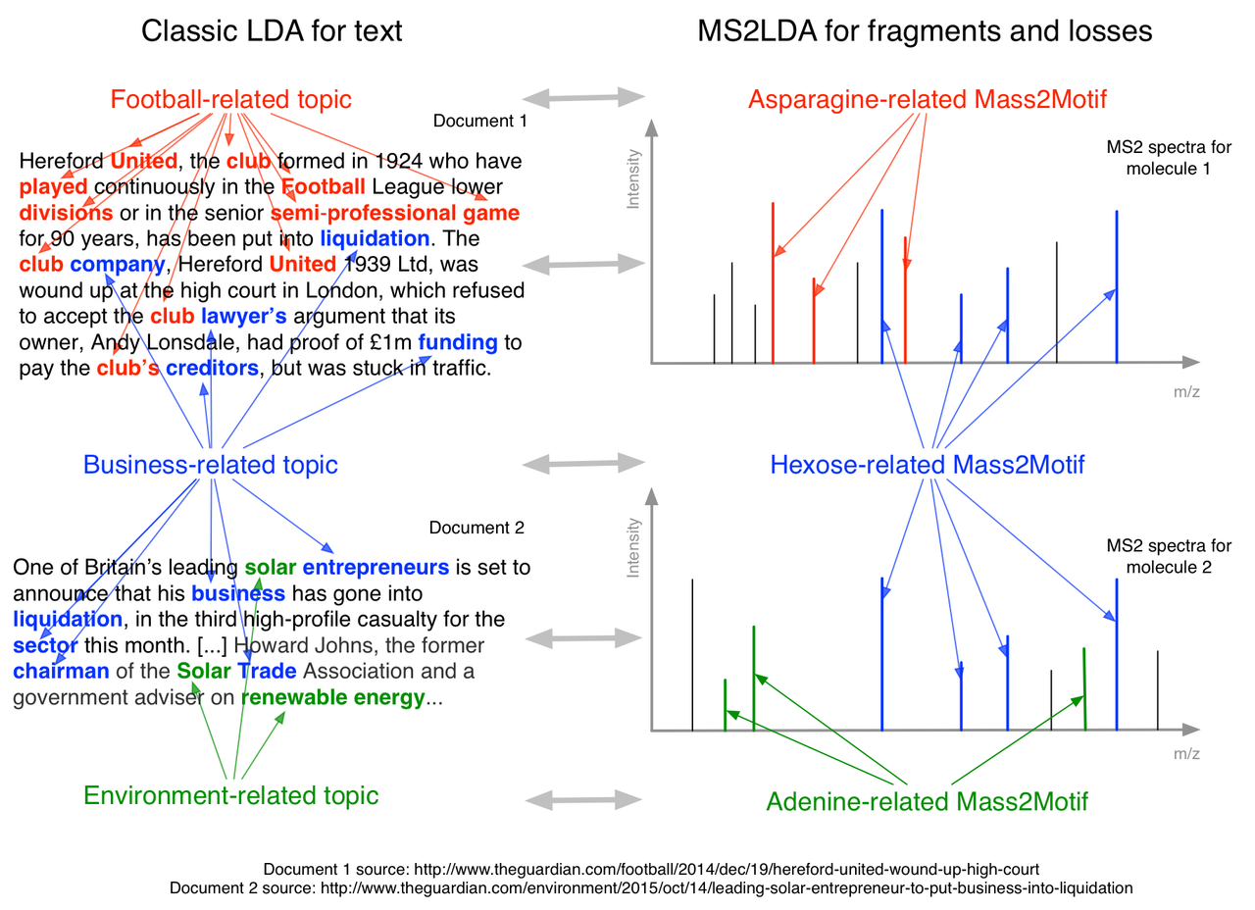

Figure 1: Analogy between LDA for text-mining and MS2LDA. In this example, we can see that traditional LDA has extracted topics that can be interpreted as ‘football related’, ‘business-related’ and ‘environment related’. Each document is a combination of different topics. In a similar manner, MS2LDA extracts different sets of concurring mass fragments or losses (Mass2Motifs) from the fragmentation spectra of precursor ions that can be interpreted as ‘Asparagine-related’, ‘Hexose-related’ and ‘Adenine-related’. Each fragmentation spectra is made up of one or more Mass2Motifs.

**2.0 Material and Methods**

## 2.1 Materials

### 2.1.1 Beer samples

We used beer samples as representative of complex mixtures of diverse biochemically relevant compound classes like amino acids, purines, and sugars. Beer extracts were acquired from three different commercially available beers and one home-brewed beer: *Beer1* is sampled from a home-brewed bottle of German Wheat Beer of which the Beer sheet is available (see section 1 in the Supporting Information); *Beer2* is sampled from a bottle of ‘Jaw Glyde Ale’ (a Golden/Blond Ale) brewed by JAW Brew (<http://www.jawbrew.co.uk/>); *Beer3* is sampled from a bottle of ‘Seven Giraffes Extraordinary Ale’ (an IPA style of beer) brewed by William Bros. Brewery Company (<http://www.williamsbrosbrew.com/beerboard/bottles/seven-giraffes>); *Beer4* is sampled from a bottle of ‘Black Sheep Ale’ (a Golden Bitter Ale) (<https://www.blacksheepbrewery.com/beers/15/black-sheep-ale>).

### 2.1.2 Beer sample preparation

Approximately 10 ml of beer was sampled from each bottle directly after opening and stored at -20 ˚C before extractions. After thawing, i) 200 µL of beer was mixed with 600 µL of methanol/chloroform, ii) then sonicated for 5 minutes at room temperature; iii) and finally centrifuged for 5 minutes (12,000 g) at room temperature. As well as the four individual extracts, a pooled aliquot of the four beer extracts was prepared. The resulting supernatants were stored at -80 ˚C until analysis.

### 2.1.3 Chemicals

HPLC-grade methanol, acetonitrile, and analytical reagent grade chloroform were acquired from Fisher Scientific, Loughborough, UK. HPLC grade H2O was purchased from VWR Chemicals, Fountenay-sous-Bois, France. Formic acid (for mass spectrometry) and ammonium carbonate were acquired from Fluka Analytical (Sigma Aldrich), Steinheim, Germany.

### **2.2 Methods**

### 2.2.1 Analytical platform

A Thermo Scientific Ultimate 3000 RSLCnano liquid chromatography system (Thermo Scientific, CA, USA) was used. That system was coupled to a Thermo Scientific Q-Exactive Orbitrap mass spectrometer equipped with a HESI II interface (Thermo Scientific, Hemel Hempstead, UK). Thermo Xcalibur Tune software (version 2.5) was used for instrument control and data acquisition.

### 2.2.2 LC settings

Column temperature was maintained at 25 °C. The HILIC separation was performed with a SeQuant ZIC-pHILIC column (150 x 4.6 mm, 5 µm) equipped with the corresponding pre-column (Merck Sequant, Darmstadt, Germany). A linear biphasic LC gradient was conducted from 80% B to 20% B over 15 min, followed by a 2 min wash with 5% B, and 7 min re-equilibration with 80% B, where solvent B is acetonitrile and solvent A is 20 mM ammonium carbonate in water. The flow rate was 300 μL/min, column temperature was held at 25 °C, injection volume was 10 μL, and samples were maintained at 4 °C in the autosampler [1].

### 2.2.3 MS and MS/MS settings

#### Positive Negative Ionization Combined Fragmentation Mode:

A duty cycle consisted of a full scan in positive ionization mode, followed by a TopN data dependent MS/MS (MS2) fragmentation event taking the 10 most abundant ion species not on the dynamic exclusion list, followed by the same two scan events in negative ionization mode. More details can be found in section 2.1 of the Supporting Information. Most importantly, MS/MS fragmentation spectra were acquired using stepped higher collision dissociation (HCD) combining 25.2, 60.0, and 94.8 normalized collision energies (NCEs) in one MS2 scan.

#### Positive or Negative Ionization Separate Fragmentation modes:

More details can be found in section 2.2 of the Supporting Information. The duty cycle consisted of one full scan (MS1) event and one Top10 MS/MS (MS2) fragmentation event.

#### Positive Negative Ionization Combined Full Scan Mode:

As for the combined files, with the following modifications: full scan (MS1) resolution was set to 70,000. The duty cycle consisted of two full scan (MS1) events.

### 2.2.4 Data acquisition

The workflow was inspired by Creek et al., 2011, where samples were measured in randomized order [30]. Details can be found in section 3 in the Supporting Information.

### **2.3 MS2LDA workflow**

The MS2LDA workflow consists of two stages: i) the data conversion stage, which prepares the acquired fragmentation data into suitable input format for the workflow, followed by ii) the Mass2Motif discovery stage, which performs topic modelling via LDA to discover mass fragmental patterns, assigns potential candidate elemental formulae to MS1 and MS2 peaks, and visualises the Mass2Motifs in an interactive environment. The complete MS2LDA workflow is schematically illustrated in Figure 2 and more details can be found in section 4 of the Supporting Information.



Figure 2: Schematic overview of the MS2LDA workflow.

2.3.1 Data Processing and Transformation

The data conversion stage of MS2LDA is implemented entirely in the ‘R’ programming language, relying on the XCMS package [31] for peak detection and the RMassBank package [32] for detecting MS1-MS2 pairs, before matrix formation by aligning MS2 fragments across different fragmentation spectra. The Mass2Motif discovery stage is implemented in Python and the visualizer [33] in Javascript/D3 on the client (web browser) side. The exploration of Mass2Motifs, however, is not limited through the browser interface alone as the modular nature of the MS2LDA components allows them to be used in constructing different analysis workflows that rely on well-established scientific Python libraries (such as NumPy and SciPy). An example notebook (*example_notebook.ipynb*) demonstrating the data processing and analysis steps performed in section IV and V of this paper is provided in our Github repository (<https://github.com/sdrogers/ms2lda>) and can be easily adapted for different data processing needs.

In short, for each sample the resulting .mzXML (full scan) files and .mzML (fragmentation) files were used as input to the data conversion stage of the MS2LDA workflow. The outputs of the data conversion stage are R data-frames (matrices) where the columns correspond to MS1 peaks (metabolites) and the rows are the unique fragment or loss features. The entries in the data-frame are the counts of occurrences of each particular fragment or loss feature in the fragmentation spectrum linked to an MS1 peak (see Figure S-1 in the Supporting Information). All data-frames are stored as text files in .CSV (Comma-separated Values) format and can be readily loaded into the next stage of Mass2Motif discovery in the workflow. In addition, m/z, retention time and intensity of all MS1 and MS2 peaks are stored in a two additional .CSV files.

## 2.3.2 Mass2Motif discovery and elemental formula assignment

The resulting .CSV files form the input of the Mass2Motif discovery stage of the workflow, which can be started from the Jupyter notebook environment. LDA was implemented in Python making use of the Numba library [34] that performs just-in-time compilation of Python to native codes for improved performance. A Gibbs sampling scheme was used for LDA inference [35], and details are provided in Supporting Information section 4.2. After the inference and candidate elemental formula assignment steps, the generated objects were serialized into binary (.project) files -- containing results from the entire analysis that can be visualized with the MS2LDAvis environment. Note that once they have been generated, these .project files can be reloaded in the notebook environment to avoid the need for repeated processing on the same input files. We have included an optional elemental formula assignment step (details in Supplementary Information section 4.3 - [36-38]) that can assign candidate elemental formulae to the mass fragments, neutral losses, and precursor ions. This aids in the interpretation of any potentially discovered patterns.

2.3.3 Computational aspects

MS2LDA relies on scripts written in R and Python and is platform-independent (tested on the Windows, Mac, and Linux operating systems.) In principle, MS2LDA is also analytical-platform independent, given that data-dependent fragmentation files containing information-rich spectra can be generated by different analytical platforms. The MS2LDA workflow accepts open data formats, such as MzXML and MzML, as well as fragmentation files in combination with peak lists generated by any peak-picking software tool, e.g. XCMS (used in this study). The scripts developed for the MS2LDA workflow can be easily extended into a web-based application accessible to the general metabolomics public. The entire MS2LDA workflow running on a typical laptop machine (Intel Core i7 3GHz, 8GB RAM) took around 3 hours to process one beer extract data set entirely, with approximately 1.5 hours spent on the data conversion stage and another 1.5 hours on the Mass2Motif discovery stage. More details are available in section 4.5 of the Supporting Information.

## 2.4 Data analysis

The MS2LDAVis module can be used to analyze and explore the discovered Mass2Motifs in the resulting project files (for details, see section 4.4 in the Supporting Information). To aid in visualization and exploration, the distributions over the features that make up the Mass2motifs and the distributions over Mass2motifs for each fragmentation spectrum can be thresholded. The default threshold values were manually selected for visualization but can be varied. In our analysis, Mass2Motifs with degrees ≥10 (i.e. that were present in ten or more spectra after thresholding) were manually inspected and annotated at different levels of confidence (see Table captions of Supporting Tables S-1 and S-2). Annotations of Mass2Motifs were established through expert knowledge and by spectral matching of the MS2 spectra containing the associated fragments and/or neutral losses to the reference spectra in MzCloud ([www.mzcloud.org](http://www.mzcloud.org/)). Key fragment or loss features from the annotated Mass2Motifs in one sample were then searched against the list of Mass2Motifs in other samples and their correspondences established if those key fragment/loss features were present in both.

**3.0 Results**

The MS2LDA workflow was independently applied to four complex biomolecular mixtures in the form of beer extracts. A standard peak-picking metabolomics data processing workflow, based on XCMS and MzMatch [31, 39], was used to detect MS1 peaks in the beer extracts to which MS2 spectra could be matched. After pre-processing and filtering, we obtained, on average (across the four datasets), 1409 and 1125 fragmented MS1 peaks in positive and negative ionization mode, respectively (see Supporting Information section 5.1 for more details). These fragmentation pattern were subjected to Latent Dirichlet Analysis (LDA) and the results from LDA inference, i.e. ‘Mass2Motifs’, were analyzed using the MS2LDAvis environment.

The MS2LDA workflow resulted in a set of 300 Mass2Motifs for each data file, which were analyzed using the MS2LDAvis environment. In each data set, MS2LDA found recurring mass fragmentation patterns, which led to the structural annotation of 30-40 Mass2Motifs in the positive ionization mode files (see Supporting Tables S-1 and S-2). Mass2Motifs could be annotated with biochemically relevant substructures such as histidine, phenylalanine, adenine, and a hexose-unit, as well as structural features such as the loss of a water molecule or a carboxyl group. For each beer extract analysed, at the selected threshold values, the number of MS2 spectra that could be explained by each annotated Mass2Motif (i.e. the degree of a Mass2Motif) follows a long-tailed distribution with some Mass2Motifs appearing in up to 200 spectra (see Supporting Info section 5.2 for more details). Across the four fragmentation files, we also observed similar profiles for the MS1 peaks and the number of Mass2Motifs that can be explained by their fragmentation spectra. Around 600 MS1 peaks are explained by a single annotated Mass2Motif, whilst around 300 are explained by two Mass2Motifs and around 50 by three Mass2Motifs. Fewer than 20 MS1 peaks can be explained by higher numbers of Mass2Motifs (indicative of their comprising several building blocks). MS2LDA, therefore, effectively reduced the entire fragmentation data file from over 5,000 MS2 spectra and 1,500 fragmented MS1 peaks down to around 35 Mass2Motifs per file. Furthermore, 70% of MS2 spectra in a file contained at least one structurally annotated Mass2Motif (see Supporting Info section 5.2 for more details). In sections 3.1 and 3.2, we demonstrate that MS2LDA can – in an unsupervised manner - extract biochemically relevant Mass2Motifs by inspecting the fragments and losses present in a set of Mass2Motifs and verifying their presence in matched standard compounds.

**3.1 Automatic, unsupervised, chemical substructure discovery**

**3.1.1 Mass2Motifs representing biochemical substructures and structural features**

MS2LDA is able to simultaneously extract biochemically relevant substructures (Mass2Motifs) and identify all MS2 spectra in which they appear. This is done in a totally unsupervised manner (based on the co-occurrence of fragments and losses across the dataset) and any particular substructure may account for only a subset of the fragments (and losses) in any particular spectrum. This is in contrast to tools such as Molecular Networking that group MS2 spectra if their entire spectra are sufficiently similar to one another and that are unable to account for the presence of neutral losses.

Several Mass2Motifs, explored in the MS2LDAvis environment, were found to be present in ≥100 MS2 spectra (we will hereafter refer to the number of MS2 spectra including a Mass2Motif as the degree of the Mass2Motif), suggesting that they represent generic structural features. For example, hexose-related Mass2Motifs were abundantly present in all positive ionization mode beer data files with degrees ranging from 58 to more than 100 (see Supporting Tables S-1 and S-2). Structural features do not have to be this common to be discovered. Less generic Mass2Motifs were also found to be biochemically relevant, as seen in Figure 3, which shows a subset of the 11 spectra that can be partly explained by Mass2Motif 19. Mass2Motif 19 was found to be representative of ferulic acid, a plant-derived hydroxycinnamic acid, known to be present in cereals, one of the ingredients of beer. The histograms indicate which of the associated mass fragments and neutral losses are consistently present throughout the MS2 spectra and explained by Mass2Motif 19 (Figure 3-D).

The ability to extract all the MS2 spectra that contain a particular Mass2Motif allows us to link these MS2 spectra via the chemical relationship encoded within the Mass2Motif. This can allow for rapid putative annotation of molecules that cannot be identified by standard means. In other words, the molecules are grouped and the chemical reason for their grouping is immediately accessible.

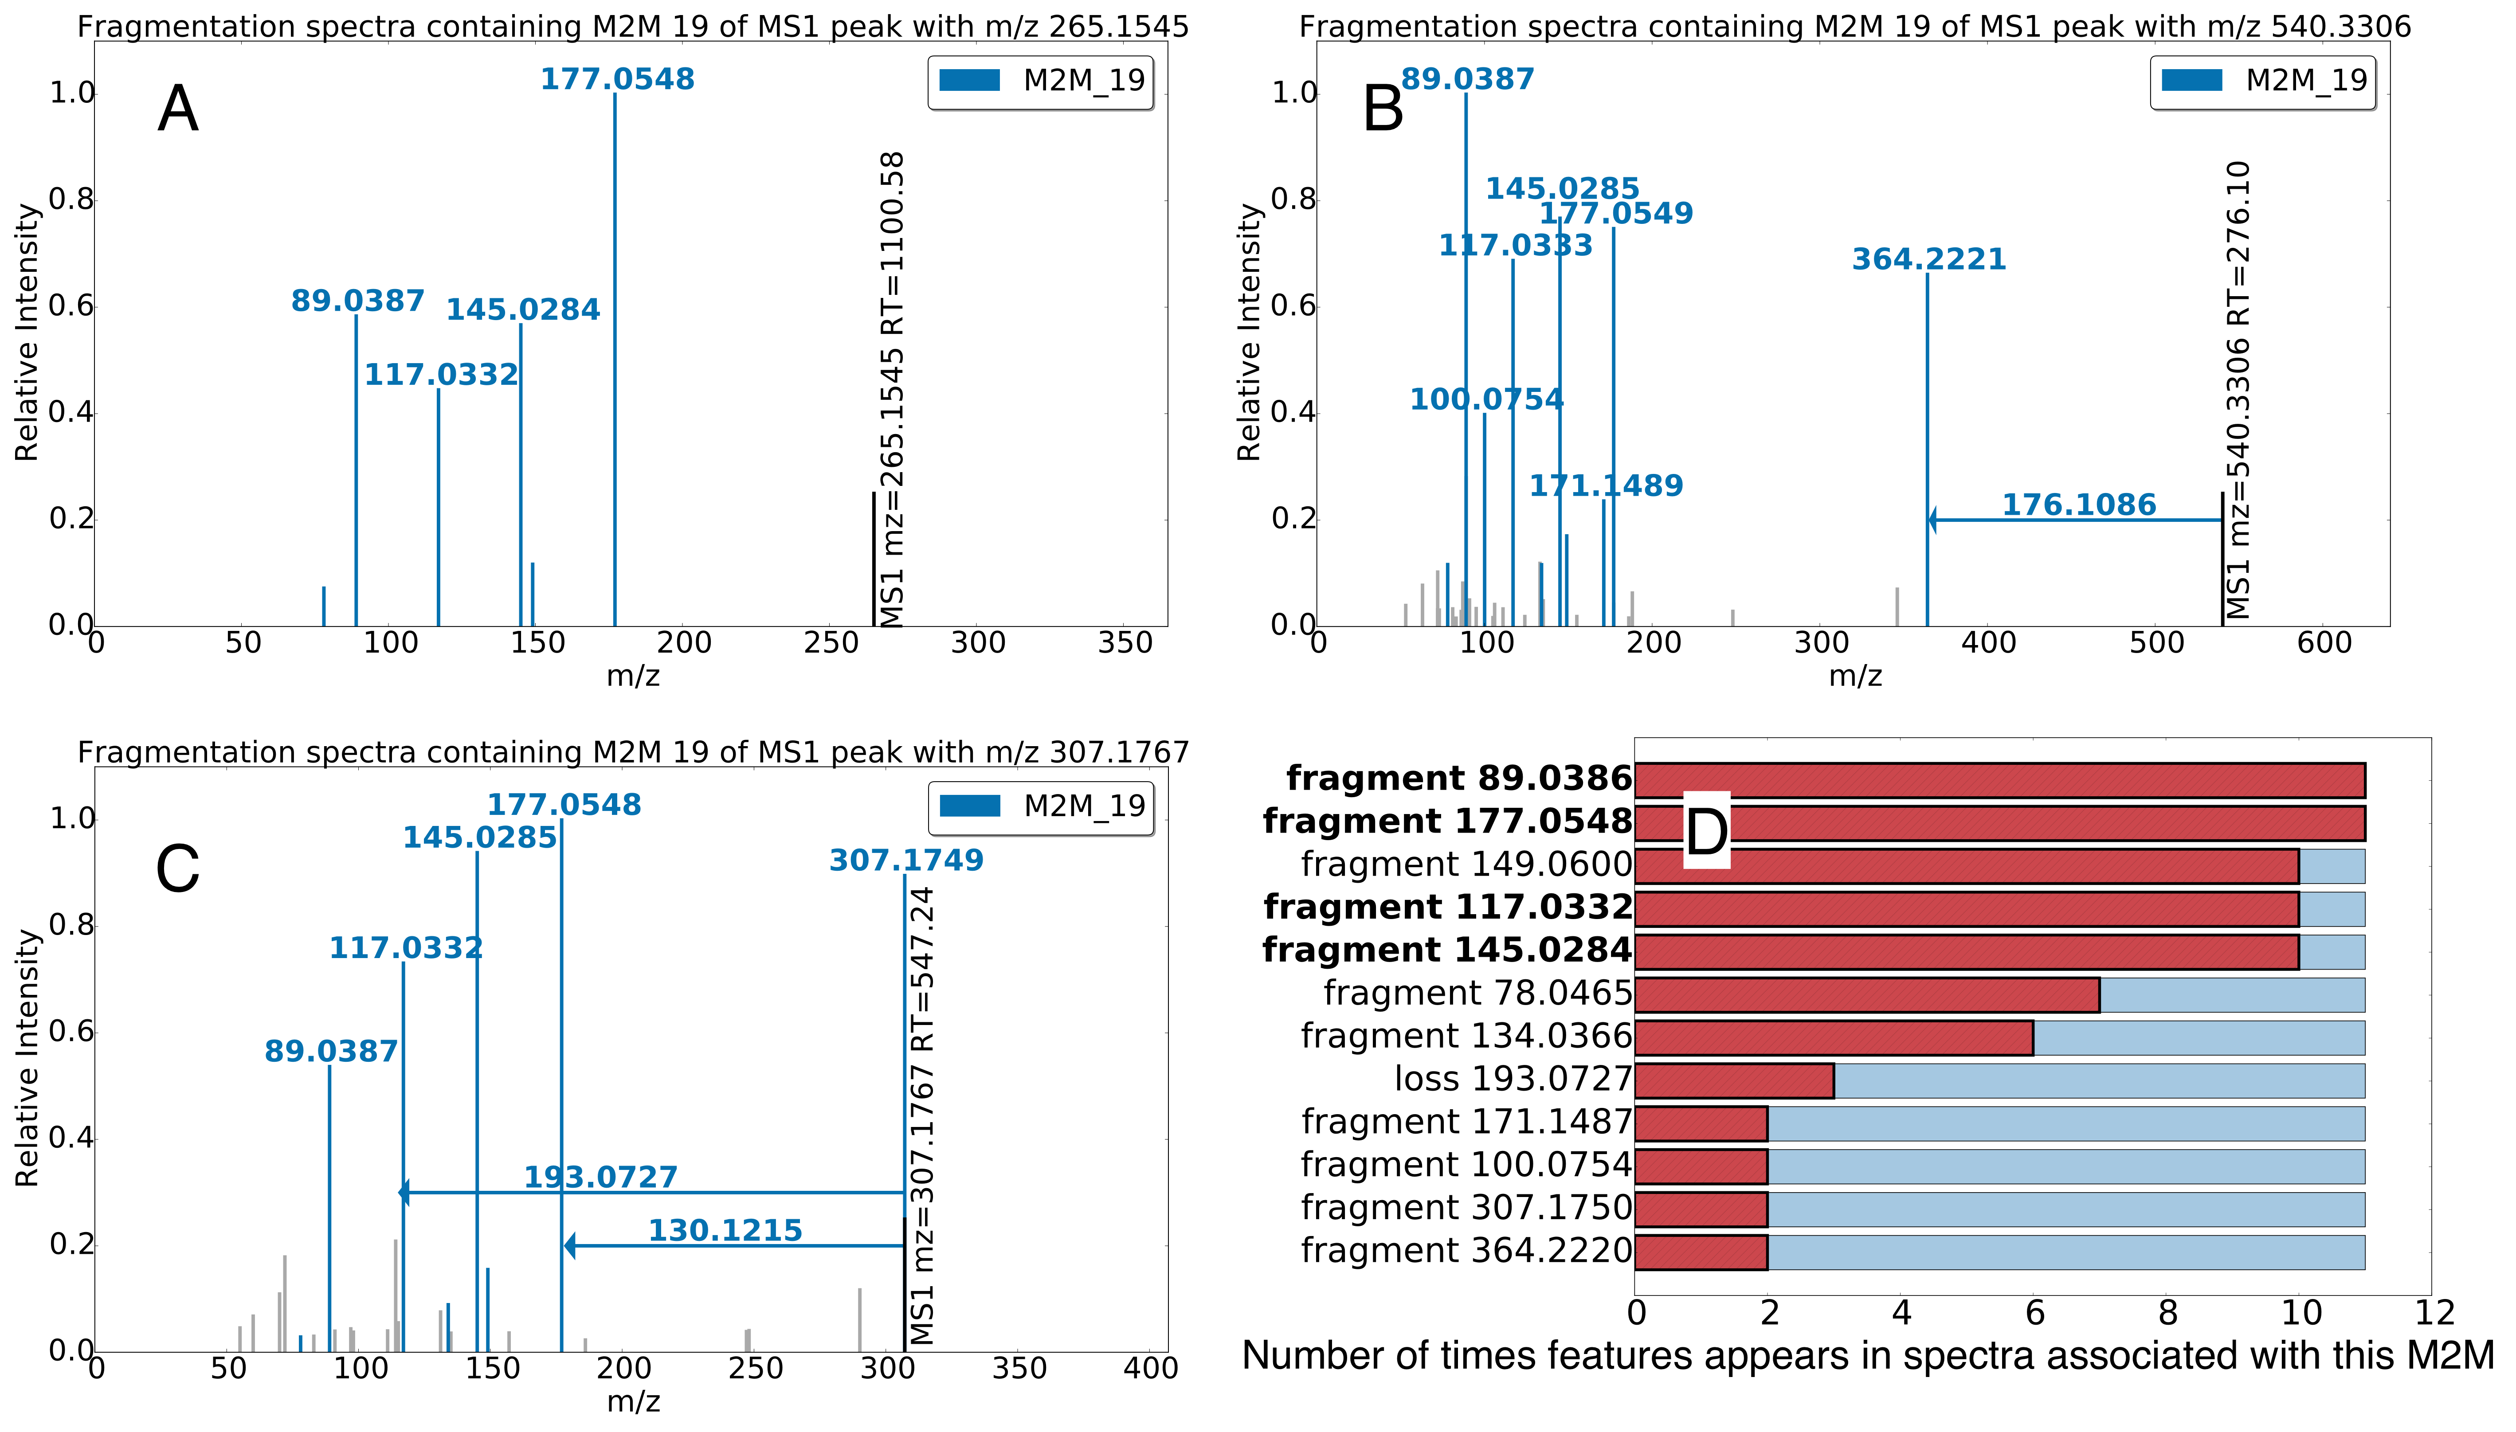

Figure 3 –Three spectra, each of which is partially explained by Mass2Motif 19, which was annotated as the plant derived ferulic acid substructure. The examples A-C from the beer3 extract positive ionization mode file have mass fragments and neutral losses (arrows originating from the precursor ions) highlighted that are included in M2M_19 (fragments not explained by M2M_19 are shown as light grey). The histogram in D shows how common each fragment / loss is in the 11 instances of M2M_19 found in the dataset. The abundant fragments with an m/z of 177.0545, 145.0284, 117.0332, and 89.0386 Da (highlighted in bold in D) are most consistently present throughout the 11 spectra explained by M2M_19. It is of note that the loss of 176.1086 Da and the fragment of 177.0575 both correspond to the complete ferulic acid moiety.

Positive ionization mode fragmentation spectra are naturally richer than negative mode spectra thereby providing larger sets of conserved fragments and allowing for more unambiguous structural annotation (see Supporting Tables S-1 and S-2). However, key negative mode fragments e.g. 78.9593 ([PO3]-) and 79.9575 ([SO3]-) m/z indicating the presence of a phosphate group and a sulphate group respectively also provide useful chemical insight. In positive ionization mode, we found Mass2Motifs containing the loss of 46.0053 Da ([CHOOH]), and the 86.0965 ([C5H12N]+) and 132.1016 ([C6H14NO2]+) m/z fragments, indicating the presence of a free carboxylic acid group and a leucine substructure, respectively. Interestingly, three positive mode Mass2Motifs pointed to the similar yet different aromatic substructures of phenylethene, cinnamic acid (cinnamate), and phenylethyleneamine (i.e., [phenylalanine – CHOOH]), demonstrating the ability of the LDA model to separate very similar substructures; see Supporting Information section 5.3 for details.

The structurally annotated Mass2Motifs cover a diverse set of biochemically relevant structural features, including amino acid related (i.e. histidine, leucine, tryptophan, and tyrosine), purine related (i.e. adenine, cytosine, and xanthine), and other biomolecules such as cinnamic acid, ferulic acid, ribose and N-acetylputrescine. Mass2Motifs related to the same substructure or structural feature were consistently found across two or more beers, despite the fact that each sample was processed through the workflow independently, demonstrating the reproducilibity of the analysis. Differences in degrees and absence of some of the Mass2Motifs in some beer extracts show that differences in metabolic composition can be reflected by the MS2LDA workflow as well. Thus, our MS2LDA workflow successfully discovered latent concurrent mass fragmentation patterns that are present in the data and are related to biochemically relevant structural features in an unsupervised manner, without platform specific training data or any *a-priori* knowledge of which fragments and losses are of interest.

**3.1.2 Matched standards are well explained by structurally annotated Mass2Motifs**

To verify that the Mass2Motifs learnt from experimental data can explain structural features of known molecules, we used the information from the standard mixes that were run along with the batch and identified those that were present in one of the beer extracts. In positive ionization mode, 45 reference compounds could be matched to peaks in the beer3 extract based on co-chromatography and their exact mass. With a threshold of 0.05 on the Mass2Motif-to-spectra distributions, 38 out of 45 matched standards have at least one associated Mass2Motif clearly demonstrating that MS2LDA is able to find conserved patterns that are present in genuine metabolites in an un-supervised, data-driven manner.

Figure 4 shows some examples selected from the matched standards with the fragmentation spectra coloured according to the Mass2Motif that explains the fragment or loss features. The spectra for Phenylalanine (Figure 4-A) and Histidine (Figure 4-B) share Mass2Motif 262, which indicates the presence of a free (underivatized) carboxylic acid group (see Table 1). Indeed the loss of CHOOH (Mass2Motif 262) is a common characteristic for those two metabolites and for many underivatized amino acids and free organic acids. In fact, the loss of CHOOH was associated to 10 out of the 18 matched amino acids structures from the standards. Additionally, the other associated Mass2Motifs in Figures 4-A and 4-B are indeed related to phenylalanine and histidine, respectively. A key characteristic of the MS2LDA approach is the unsupervised decomposition of MS2 spectra into their biochemically relevant components. For example, in each of Figures 4-A to 4-D we observe the spectra being decomposed into 2 or more Mass2Motifs. We know of no other method that can do this in an unsupervised manner – i.e. without training spectra consisting of known structures or *a priori* knowledge of interesting combinations of fragments and/or losses. We will demonstrate later how the presence of multiple substructures can be very useful in putatively annotation previously unknown metabolites. All the spectra of matched standards spectra with their Mass2Motif annotations can be found in a notebook in the MS2LDA GitHub repository.

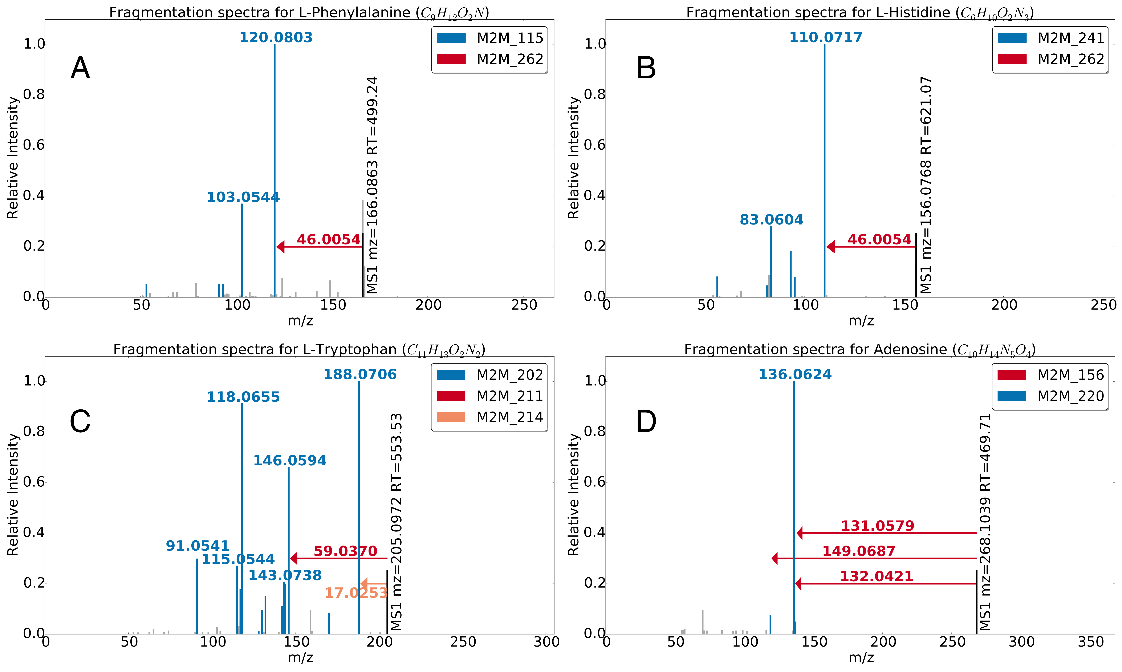

Figure 4 – Multi-coloured Mass2Motif spectra of identified metabolites A) L-Histidine, B) L-Phenylalanine, C) L-Tryptophan, and D) Adenosine. Annotated motifs (see Table 1) are indicated in the fragmentation spectra, with coloured mass fragment peaks and coloured arrows for the neutral losses.

|  |  |  |  |  |  |
| --- | --- | --- | --- | --- | --- |
| Mass2Motif (M2M) | Annotation | Degree | | Fragment or Loss Features | Elemental Formula |
| 115 | [phenylalanine-CHOOH]-based substructure. | | 28 | fragment_120.0808,  fragment_103.0546,  fragment_91.0541 | C8H10N,  C8H7,  C7H7 |
| 156 | [Ribose (pentose, C5-sugar)-H2O]-related loss. | | 22 | loss_132.0421 | C5H8O4 |
| 202 | [tryptophan-NH3]-related substructure. | | 15 | fragment_118.0654,  fragment_117.0571,  fragment_91.0541,  fragment_130.0645  fragment_188.0706 | C8H8N,  C8H7N,  C7H7,  C9H8N,  C11H10NO2 |
| 211 | N-acetylputrescine substructure. | | 24 | loss_59.0370,  fragment_114.0912,  fragment_72.0447,  fragment_60.0448 | C2H5NO,  C6H12NO,  C3H6NO,  C2H6NO |
| 214 | Amine loss. | | 57 | loss_17.0247 | NH3 |
| 220 | Adenine substructure. | | 32 | fragment_136.0629,  fragment_119.0351 | C5H6N5,  C5H3N4 |
| 241 | Histidine substructure. | | 21 | fragment_110.0718,  fragment_156.0769,  fragment_93.0450,  fragment_95.0608 | C5H8N3,  C6H10N3O2,  C5H5N2,  C5H7N2 |
| 262 | Combined loss of H2O and CO – indicative for free carboxylic acid group (COOH). | | 90 | loss_46.0053 | CH2O2 |

Table 1– Annotations of the Mass2Motifs associated to the fragmentation spectra of the standard peaks that are shown in Figure 4. The degree of a Mass2Motif indicates the number of MS2 fragmentation spectra in the beer3 positive ionization mode data having fragment or loss features that can be explained by the Mass2Motif (at the specified thresholding level).

It is noteworthy that multiple Mass2Motifs can include the same fragment in a single MS2 spectrum, i.e. the fragments 110.0718 (C5H8N3, [M+H]+) and 120.0808 (C8H10N, [M+H]+) in Figures 4-A and 4-B are explained by Mass2Motifs 241 and 115 respectively but are also each explained by the 46.0054 loss of Mass2Motif 262. Figure 10-C displays the MS2 spectrum of tryptophan, which is associated with the tryptophan-substructure Mass2Motif 202. The amine loss is the primary small loss associated with tryptophan, which is favoured over the loss of CHOOH for this amino acid. Finally, Figure 10-D is the MS2 spectrum of adenosine, which consists of an adenine molecule conjugated to a ribose sugar molecule. The two associated Mass2Motifs (156, 220) represent these two biochemically relevant structural features (i.e., adenine substructure and a loss corresponding to a ribose sugar), and the fragment 136.0629 (C5H6N5, [M+H]+) is related to both Mass2Motifs. This example clearly demonstrates the manner in which MS2LDA can decompose molecules into their constituent building blocks, which has clear potential in metabolite annotation.

It should be added that not all associated motifs could explain a relevant structural feature in the fragmented reference compounds. However, only 6 out of the 38 matched MS2 spectra were explained by structurally unrelated Mass2Motifs. The remaining 32 matched metabolite standards’ fragmentation spectra contain relevant Mass2Motifs with the structural annotation constructed from the complete experimental data file (without using information about the standards themselves). This demonstrates the biochemical relevance of those validated Mass2Motifs and the potential of the workflow to effectively reduce a fragmentation data set to its relevant conserved motifs.

**3.1.3 MS2LDAvis allows quick fragmental analysis to determine conserved motifs**

We have demonstrated that applying LDA to DDA data can extract conserved patterns that are indicative of biochemically relevant substructures, thereby transforming the data to expose chemical relationships between metabolites. However, despite this transformation, the output of LDA is still complex (>1000 precursor ions and ~300 Mass2Motifs). To overcome this, MS2LDA includes a visualisation module that enables users to rapidly explore the discovered Mass2Motifs and the induced relationships between metabolites. The right panel of the MS2LDAvis environment includes two different frequency histograms that can be used to determine the conserved fragments or losses consistently present in the spectra associated with a Mass2Motif. These provide counts of objects of interest at Mass2Motif level and entire data set level, as shown in Figure 5.

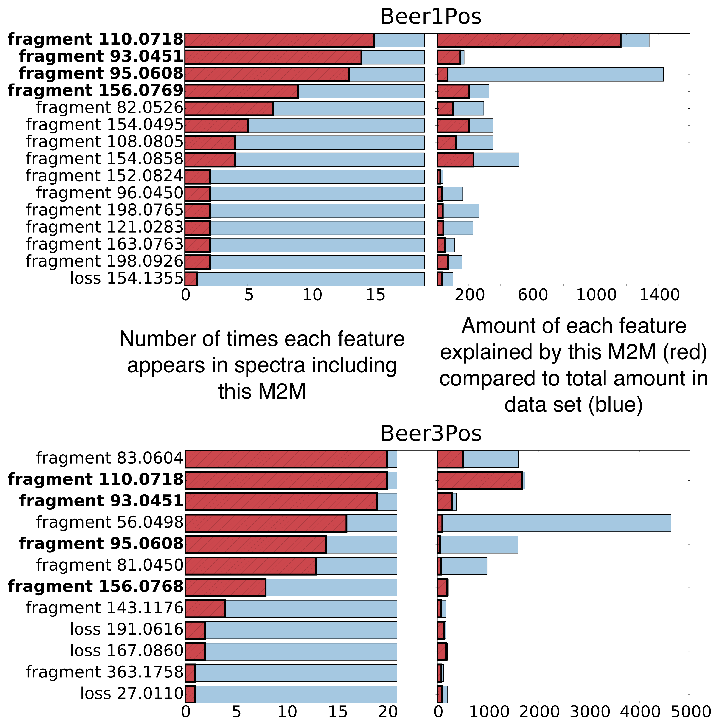

D

B

A

C

Figure 5 – Similar sets of fragment and loss features can be seen in the MS2LDAVis ‘Mass2Motif Feature Frequency’ histograms for histidine-related Mass2Motifs in the positive ionization mode of the beer1 (top) and beer3 (bottom) extracts. In both cases the left-hand panel shows the number of times each feature appears in spectra associated with this Mass2Motif and the right-hand panel shows the proportion (red) of the total abundance (blue) of this feature within the dataset. For example, this Mass2Motif explains the vast majority of the total abundance observed for the fragment with mass 110.0718. Conversely, although the fragment with mass 95.0608 appears often in the spectra associated with this Mass2Motif, it appears widely elsewhere too. Because the analyses of the four beers are done separately, the fragment masses do not match exactly from one sample to another. The small differences in fragment masses displayed for the two different beer data sets are a result of their independent analysis, i.e., the binning during the data transformation process. In addition, the low abundant and widely present fragment 56.0498 is part of the histidine-related Mass2Motif in beer3, but is not present in beer1.

The ‘Mass2Motif Feature Frequencies’ histogram (Figure 5-A, 5-C) displays the counts of fragmentation spectra including particular fragment or loss features explained by this Mass2Motif. For example, Figure 5-A and 5-C shows this histogram for the Mass2Motifs related to the histidine substructure found in the beer1 and beer3 positive ionization mode data set respectively. We find very similar histidine Mass2Motifs in all four beers, with the fragments 110.0718 ([C5H8N3]+) and 93.0450 ([C5H5N2]+) m/z being most consistently present in the Mass2Motifs across all four beers, demonstrating the reproducibility of MS2LDA across independent datasets.

On top of motif-specific views, the MS2LDAVis environment also provides the ‘Mass2Motif Global Frequencies’ histogram (Figure 5-B, 5-D), which visualises the proportion of the global total intensity of the fragment or loss features that is explained by this Mass2Motif. This provides an indication of how unique a fragment or loss is within the complete set of fragments or losses. We see from Figures 5-B and 5-D that globally, most of the observed fragments with m/z 110.0718 ([C5H8N3]+) are explained by the histidine-related Mass2Motif, whereas only a small fraction of the mass fragments with m/z 95.0608 are explained by the histidine-related Mass2Motif. This demonstrates a key strength of MS2LDA. If we manually extracted all spectra including m/z 95.0608 we would be faced with a vast number of spectra. By learning the relationships that exist between groups of fragments and losses, MS2LDA is able to provide us with groups of metabolites that are much more likely to be chemically related than spectra or metabolites collected based on the presence of one fragment only.

Small differences in the Mass2Motif-related fragment mass values were observed between different beers. This can be explained by the four independent LDA models that were run each with different experimental data as starting point. This is also the reason for the differences in fragment and loss composition of the Mass2Motif related to the same histidine substructure. Nevertheless, remarkably similar patterns were found across the four beers, suggesting the presence of histidine substructures in the associated fragmentation spectra. This illustrates how the MS2LDA workflow facilitates quick determinations of key mass fragments or neutral losses that co-occur in mass fragmental data sets.

**3.1.4 Mass2Motifs aid in classification and annotation of metabolites**

The structurally annotated Mass2Motifs can aid in the metabolite annotation step. Instead of a spectrum-by-spectrum comparison to reference MS2 spectra, MS2LDA automatically assigns the concurring patterns to spectra in the complete data set. In the beer extracts, on average 73% of the fragmented MS1 features are explained by at least one of the structurally annotated Mass2Motifs (see also Supporting Information section 5.1). This suggests that a large percentage of metabolites can be automatically classified according to function (based on presence of functional groups or as a part of biological pathways). To provide additional insight, we performed spectral matching for the ferulic acid related spectra using both the Nist MS/MS database for small molecules (http://chemdata.nist.gov/mass-spc/msms-search/ ) and MassBank [7]. This did not return any ferulic acid-related hits. Moreover, out of 7 annotated metabolites explained by Mass2Motif 19 (ferulic acid substructure), only one resulted in a ferulic acid-related hit (see Supporting Information, Section 5.4). Similarly, the beer metabolites explained by Mass2Motifs related to histidine, tyrosine, and tryptophan were subjected to spectral matching. In total, 33 metabolites were annotated using MS2LDA, of which 15 showed hits related to the annotated Mass2Motif substructure, including 7 correct matches. These results demonstrate how MS2LDA effectively recognizes core substructures in mass spectral data and can serve as aid in classification and annotation of metabolites. Critically, it does this by matching only small portions of the spectra (substructures) rather than relying on complete spectral matches. Thus, for this subset of Mass2Motifs, spectral matching allows classification of 45% of the metabolites that were member of one of the four Mass2Motifs and could so be classified by MS2LDA. In addition, MS2LDA can find chemical relationships such as the presence of a free carboxylic acid group (neutral loss based) which spectral matching is unable to do. . We can also start structural elucidation based on structural features or substructures present in the molecule, as we further elude on in section 3.2.2. While we cannot be certain that all the associations found by MS2LDA are structurally informative and valid we are encouraged by the validity of the majority of associations present for the standards compounds.

**3.2. MS2LDA fragmental network as an alternative to spectral clustering**

**3.2.1 MS2LDAvis allows for graphical visualization of a topic-modelled fragmentation set**

The MS2LDA workflow not only decomposes the mass fragmental data set into conserved biochemical building blocks; it can also build bipartite networks from on the induced chemical relationships (with nodes representing Mass2Motifs and metabolites) that can be visualized in the MS2LDAVis environment (Figure 6). In the network, circles represent Mass2Motifs and their size is proportional to the degree of the Mass2Motif (the number of spectra in which it is found). Small squares represent precursor ions (fragmented MS1 features from which common fragments emerge). The graphical view enables researchers to rapidly explore major Mass2Motifs and how they are connected to other Mass2Motifs. The network is interactive – clicking on particular Mass2Motifs allows the user to scroll through all of the associated parent ions.

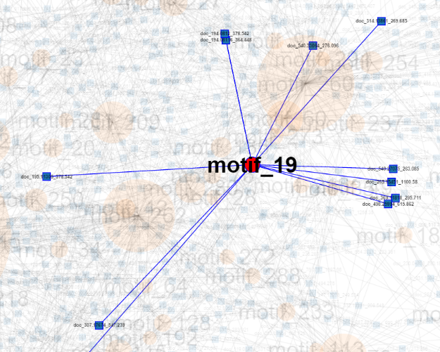 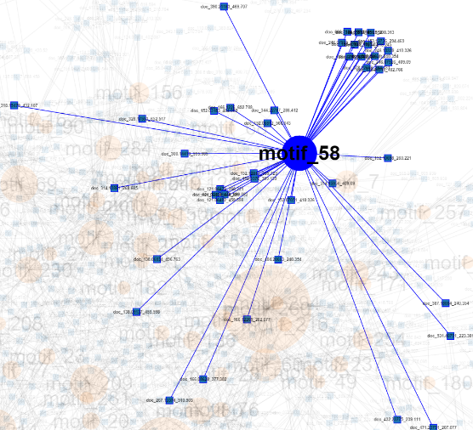

Figure 6 – The graphical network visualization with Mass2Motif 19 highlighted (ferulic acid substructure) and Mass2Motif 58 highlighted (ethylphenol substructure) in the MS2LDAvis environment. In the network, fragmentation spectra (square) are connected to the Mass2Motif (circles) that can explain their structural features or substructures.

**3.2.2 MS2LDA fragmental networks showing multiple motifs in one metabolite**

As previously described, the LDA model allows for multiple Mass2Motifs (conserved patterns) to be present in one MS2 fragmentation spectrum. Figure 7 shows two Mass2Motifs (M2M_19 and M2M_58) as well as the fragmentation spectra for three MS1 ions. One of these ions includes just M2M_19, one just M2M_58 and the final one includes both. M2M_19 and M2M_58 have been structurally annotated as ferulic acid and ethylphenol respectively. In a standard clustering approach, it is likely that these two mass2motifs would each form their own cluster and the shared ion would be forced to join one or the other, resulting in it being given a single classification. MS2LDA on the other hand, allows the MS1 ion to be assigned to both substructures. In this example, the combination of the two annotations allows us to annotate it as feruoyltyramine (314.1386 m/z; [C18H20NO4]+). Spectral matching did not yield any hit related to either ferulic acid or the ethylphenol substructure (spectra were searched against the MassBank database, see Table S-7 in the Supporting Information, section 5.4).

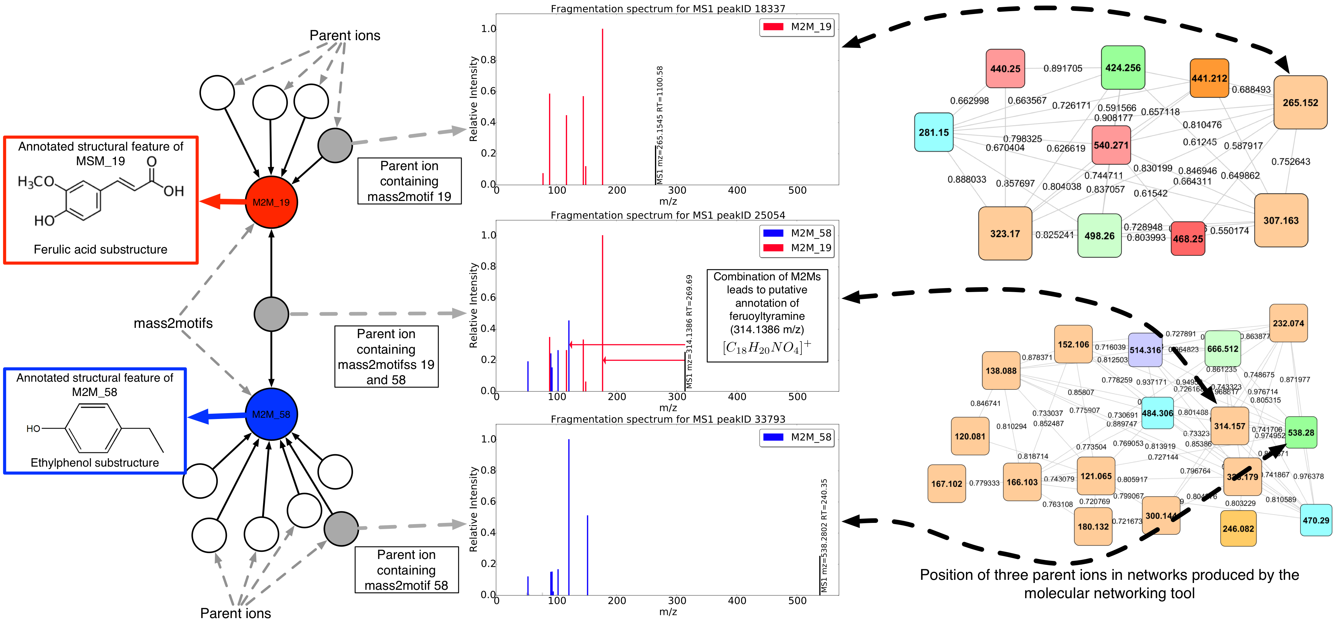

Figure 7 –Multi-coloured Mass2Motif MS2 spectra of beer metabolites observed in positive ionization mode. The annotated Mass2Motifs 19 and 58 were found to be representative for ferulic acid and ethylphenol, respectively. In total 11 and 42 MS1 features in the beer3 data set were explained by those two Mass2Motifs respectively. Of those, one was explained by both Mass2Motifs, aiding in its annotation as feruoyltyramine (314.1386 m/z; [C18H20NO4]+). On the right of the plot we show the clusters containing these three MS1 features created using the molecular networking tool [13]. This resulted in clusters of homologous metabolites of positive ionization mode fragmentation files of four beers in one analysis, with the ferulic acid based cluster (top) and tyramine (ethylphenol) based cluster (bottom). The coloring of the nodes is dependent on their presence across the different beer extracts and the node size is proportional to the number of unique beer extracts the node fragmentation spectra are found in. Using this approach, the compound containing both Mass2Motifs has to be forced into one cluster or the other, losing the clear chemical connection with the other substructure.

**3.2.3 MS2LDA as an alternative data representation to Spectral Clustering**

In molecular networking and equivalent clustering approaches, spectral similarity is defined across the whole spectrum and molecules must share a high proportion of similar fragment ions to be classed as similar. Two spectra that share a common subset of fragments but differ in other parts of the spectrum are less likely to be connected in the graph. This is potentially problematic if the functionally relevant part of the molecule is only responsible for a small proportion of its observed spectra.

To explore the performance of MS2LDA against a more standard clustering approach, we have compared MS2LDA with a model that is identical except for not allowing each spectra to be explained by more than one Mass2Motif (a multinomial mixture model, see Supporting Figure S-6 in section 5.5). For the same number of Mass2Motifs, MS2LDA has consistently lower perplexity (a standard approach in the analysis of probabilistic text models; lower is better) suggesting that allowing for spectra to consist of multiple building blocks (Mass2Motifs) is appropriate for this data.

To compare the results from the MS2LDA workflow and molecular networking, we applied the molecular networking tool on our data sets [13] (see also Supporting Information section 5.6 for details). Manual inspection of the resulting molecular network obtained from the combined analysis of the four beer data sets resulted in structurally annotated clusters based on core structures for ferulic acid, histidine, tyrosine and tyramine, as well as hydroxycinnamic acid, guanine and citric acid, in positive and negative ionization mode respectively. After a more detailed analysis of the Mass2Motifs related to ferulic acid, histidine, tyrosine, and tryptophan, we could annotate ferulic acid conjugates to polyamine structures like putrescine, histidine metabolites conjugated to hexose and organic acid moieties as well as a family of indole (tryptophan) related metabolites. Two of those annotated beer metabolites were found to be dipeptides, whereas all other represent conjugations of amino acids with other compound classes. Figure 7 right-top and right-bottom displays the clusters for ferulic acid and tyramine (ethylphenol) from molecular networking. Our comparison found overlap in cluster membership within the molecular network and MS1 peaks explained by the related Mass2Motif. The precursor masses found by the molecular networking tool corresponded well with those that were explained by Mass2Motif 58 and 19, respectively.

To directly compare the molecular networking and MS2LDA approach, we selected representative spectra from the beer3 extract that have been put by molecular networking into separate tyramine and ferulic acid based clusters, alongside one other MS2 spectrum that contains fragmental structures that can be described by both clusters (i.e. having both Mass2Motif 58 and 19, as shown in Figure 7). The cosine similarities of spectra were computed against each other using the same binning size for vectorization (0.005 Da) as used for the molecular network creation. As in molecular networking, the cosine similarities matrix in Supporting Figure S-7 (section 5.6 in the Supporting Information) shows 2 natural clusters emerging if these spectra were to be clustered by their cosine similarities. However, only MS2LDA could detect two annotated substructures in a metabolite spectrum, which was classified by molecular networking to belong to one of the cluster only.

**4. Discussion**

Our motivation for the introduced MS2LDA approach was the idea that conserved fragments and neutral losses are potentially indicative of substructures shared by multiple molecules. Our results demonstrate that this is indeed the case. None of the tools released so far allows for substructure mining in an unsupervised manner from a fragmentation data set while also allowing for multiple structural features or substructures to be present within one fragmented metabolite. As shown in section 3.2.2, the key asset of LDA (topic modelling) is that it allows for each molecule to be composed of several Mass2Motifs, thus MS2LDA can group molecules that share substructures but do not necessarily have high similarity across their entire MS2 spectra. We show that MS2LDA effectively reduces complex fragmentation data sets into fragmented metabolites explained by one or more patterns of concurring mass fragments or neutral losses (which we termed Mass2Motifs.) Furthermore, we could structurally annotate those Mass2Motifs with biochemically relevant structural features (Supporting Tables S-1 and S-2), supporting our key assumption that biological extracts consist of molecular building blocks that can be found in mass fragmentation spectra. The majority of those annotated Mass2Motifs were independently found in several of the beers. This shows the effectiveness of the data reduction strategy performed by MS2LDA. While the molecular content of the beers differed slightly, similar metabolites and Mass2Motifs were found to be present in the input files analyzed. Thus, MS2LDA not only successfully discovered the conserved mass fragmental patterns present within one fragmented beer extract, but also across different fragmentation files.

As is true for most tools working with mass spectrometry fragmentation data, MS2LDA relies on correct and clean MS1 peak - MS2 spectrum pairs. As a result of the stochastic nature of data-dependent fragmentation and the co-elution of isobaric compounds (molecules with nearly identical m/z values), some MS2 spectra can be contaminated by fragments of other unrelated molecules, and possibly cause incorrect associations between Mass2Motifs and MS1 peaks. As such, MS2LDA works best for complex mixtures where a large number of metabolites (MS1 peaks) are fragmented and information-rich MS2 spectra are produced using for instance, ramped energy or stepped energy (as was used in our study.) Additionally, MS2LDA benefits from high-resolution mass spectrometry fragmentation spectra, as an increased amount of mass fragments and neutral losses can be differentiated. This makes a difference even at the lower mass range of 50 -70 m/z (see Supporting Information section 5.7).

While the Mass2Motifs resulting from the MS2LDA workflow need to be manually annotated, once this essential step has been performed, the validated structural features or substructures can be propagated onto all MS2 spectra that can be explained by a particular Mass2Motif. In order to assess the potential of automated annotation of Mass2Motifs, we reconstructed MS2 spectra from 32 fragment-based Mass2Motifs from beer3 (positive mode) and performed spectral matching to the NIST MSMS library (nist_msms) and MassBank. This resulted in 19 relevant spectral matches where the manual annotation was the same or very similar to the best hit of Nist_msms or MassBank. All results and examples of ‘reconstructed Mass2Motif spectra’ can be found in the Supporting Information section 5.8. These results demonstrate that performing automated annotation of conserved patterns could be integrated as a first step after Mass2Motif discovery and would subsequently allow these annotations to be propagated to molecules that use this Mass2Motif. In each beer file, the number of Mass2Motifs that we could meaningfully annotate at higher confidence represents 10-15% of the total number of Mass2Motifs ($K$) discovered by LDA. The variable $K$ was selected in our study based on cross-validation experiments that maximizes the likelihood on the testing data. However, topic model parameters that result in better held-out likelihood do not necessarily correspond to results most interpretable by human [40] or in our application, most meaningful in the chemical sense. Interpretation of topic modelling output (on any data set) remains an open research problem. Our proposed solution to this challenge of interpretation takes the form of MS2LDAVis, a visualization environment specifically tailored for the interactive exploration of Mass2Motifs and their associated fragmentation features.

An important step in untargeted mass spectrometry-based metabolomics experiments is the metabolite annotation and identification step. This step has often been the bottleneck in high-throughput metabolomics as only a small number of metabolites can be reliably identified through comparisons to reference library. Furthermore, following the ‘classical approach’ of spectral matching, precursor ions are matched one-by-one, and precursor ions that do not show good hits to measured or theoretical reference spectra either have to be manually investigated (a laborious task) or are overlooked for subsequent analysis (a significant loss of potentially useful information). In addition, considering each MS2 spectrum in isolation ignores structural relationships between MS2 spectra (and therefore metabolites) that become visible when the dataset is viewed in its entirety. We show that our proposed MS2LDA workflow can assist the identification step by automatically assigning possible substructures to a fragmented LC-MS peak based on mass peak patterns present in its MS2 spectrum. MS2LDA can thus quickly classify MS1 peaks into functional relevant classes -- without necessarily knowing the complete structure of the metabolite. On average, more than 70% of the fragmented metabolites were explained by one or more structurally annotated Mass2Motifs. Compared to a recent beer metabolomics paper where 2-3% of the high-abundant molecular features could be classified, annotated, or identified [11], our approach demonstrates effective deciphering of the complex mixture a beer extract represents. In addition, if the same experimental conditions and sample types are used, existing Mass2Motif annotations can be used as starting point for analyzing future ‘fragmentome’ data.

**5. Conclusions**

In this paper, we introduce MS2LDA, a pipeline that effectively reduces fragmentation data files by combining a text-mining algorithm and mass fragmental analysis. The key assets of the workflow are the preparation of a MS1-MS2 matrix that allows for efficient LDA analysis, and the graphical visualization of the resulting reduced data file consisting of Mass2Motifs and their assigned precursor ions – mass fragmentation spectral pairs. The LDA analysis resulted in numerous informative patterns of concurrent mass fragmental and neutral loss, termed Mass2Motifs, which we could annotate with diverse biochemical relevant core structures in beer extracts. This approach is markedly different from other recently released advanced spectral analysis tools as it allows for multiple Mass2Motifs to be associated with one metabolite, and also facilitates quick determination of the key mass fragments or neutral losses that are part of a conserved structural motif.

MS2LDA is unsupervised and platform-independent (both in the computational and analytical sense) and therefore, we expect it to be useful for a wide area of biological applications ranging from clinical metabolomics, natural products research, to toxicological applications. Our proposed approach is also novel in our focus of pattern mining on the MS2 fragmentation data alone to aid in identification of functional classes of metabolites. This stands in contrast to the common usage of fragmentation data to identify a particular metabolite by one-by-one comparisons to spectral databases. In the nearby future, we see great potential in developing a larger library of validated Mass2Motifs from data sets produced on a diverse range of analytical platforms and different sample types. We are also planning to explore the extension of the basic LDA model used in MS2LDA to handle Mass2Motif inference from multiple data sets at once. Prior information on which candidate Mass2Motifs an MS2 spectrum might have could also be incorporated into the MS2LDA workflow, resulting in a semi-supervised model, and different generative process, such as the discussed Comparative Fragmentation Modelling can be used to model the fragmentation spectra.

**6. Acknowledgements:**

The authors thank Dr. Emma Schymanski, Dr. Tony Larson, and Dr. Samuel Bertrandt for their helpful scientific discussions and assistance with implementation of R scripts from: RMassBank (ES), xcmsFragments (TL), and the 7 golden rules (SB). The authors thank Dr. Niels van den Broek for helpful discussions on acquisition of mass fragmentation spectra. JJJvdH was supported by the Wellcome Trust [grant no. 097821/Z/11/B]. MPB was funded as part of the Wellcome Trust core grant to the Wellcome Trust Centre for Molecular Parasitology (085349). JW was supported by a SICSA PhD studentship. SR was supported by BBSRC [grant no. BB/L018616/1].

**Supporting Information:**

Supporting Information is available with this manuscript – the following files can be found online:

Supporting Table S-1 (word document) - Table with Mass2Motifs (MSMs) discover in the four positive ionization mode fragmentation files of the beer extracts

Supporting Table S-2 (word document) - Table with Mass2Motifs (MSMs) discover in the four negative ionization mode fragmentation files of the beer extracts

Supporting Material containing Supporting Sections 1 – 5 (word document)

Cytoscape session files for Molecular Networking results of beer extracts in positive and negative ionization modes.

We plan to submit the data to Metabolights repository and to make the molecular networking results publically available on the website as well.

**References**

1. van der Hooft, J.J.J., et al., *Structural elucidation of low abundant metabolites in complex sample matrices.* Metabolomics, 2013. **9**(5): p. 1009-1018.

2. Kind, T. and O. Fiehn, *Metabolomic database annotations via query of elemental compositions: Mass accuracy is insufficient even at less than 1 ppm.* Bmc Bioinformatics, 2006. **7**: p. -.

3. Misra, B.B. and J.J.J. van der Hooft, *Updates in metabolomics tools and resources: 2014–2015.* ELECTROPHORESIS, 2016. **37**(1): p. 86-110.

4. Hufsky, F., K. Scheubert, and S. Böcker, *Computational mass spectrometry for small-molecule fragmentation.* TrAC Trends in Analytical Chemistry, 2014. **53**(0): p. 41-48.

5. Dührkop, K., et al., *Searching molecular structure databases with tandem mass spectra using CSI:FingerID.* Proceedings of the National Academy of Sciences, 2015. **112**(41): p. 12580-12585.

6. Ridder, L., et al., *Automatic Chemical Structure Annotation of an LC–MSn Based Metabolic Profile from Green Tea.* Anal. Chem., 2013. **85**(12): p. 6033-6040.

7. Horai, H., et al., *MassBank: A public repository for sharing mass spectral data for life sciences.* Journal of Mass Spectrometry, 2010. **45**(7): p. 703-714.

8. Wishart, D.S., et al., *HMDB 3.0—The Human Metabolome Database in 2013.* Nucleic Acids Res., 2013. **41**(D1): p. D801-D807.

9. Jeffryes, J., et al., *MINEs: open access databases of computationally predicted enzyme promiscuity products for untargeted metabolomics.* Journal of Cheminformatics, 2015. **7**(1): p. 1-8.

10. Ridder, L., et al., *In Silico Prediction and Automatic LC–MSn Annotation of Green Tea Metabolites in Urine.* Analytical Chemistry, 2014. **86**(10): p. 4767-4774.

11. Allen, F., R. Greiner, and D. Wishart, *Competitive fragmentation modeling of ESI-MS/MS spectra for putative metabolite identification.* Metabolomics, 2015. **11**(1): p. 98-110.

12. Garg, N., et al., *Mass spectral similarity for untargeted metabolomics data analysis of complex mixtures.* International Journal of Mass Spectrometry, 2015. **377**: p. 719-727.

13. Yang, J.Y., et al., *Molecular Networking as a Dereplication Strategy.* Journal of Natural Products, 2013. **76**(9): p. 1686-1699.

14. Watrous, J., et al., *Mass spectral molecular networking of living microbial colonies.* Proceedings of the National Academy of Sciences, 2012. **109**(26): p. E1743–E1752.

15. Nguyen, D.D., et al., *MS/MS networking guided analysis of molecule and gene cluster families.* Proceedings of the National Academy of Sciences, 2013. **110**(28): p. E2611-E2620.

16. Ma, Y., et al., *MS2Analyzer: A Software for Small Molecule Substructure Annotations from Accurate Tandem Mass Spectra.* Analytical Chemistry, 2014. **86**(21): p. 10724-10731.

17. Blei, D.M., A.Y. Ng, and M.I. Jordan, *Latent dirichlet allocation.* J. Mach. Learn. Res., 2003. **3**: p. 993-1022.

18. Daly, R., et al., *MetAssign: Probabilistic annotation of metabolites from LC–MS data using a Bayesian clustering approach.* Bioinformatics, 2014.

19. Tsai, T.-H., et al., *Profile-Based LC-MS Data Alignment--A Bayesian Approach.* IEEE/ACM Trans. Comput. Biol. Bioinformatics, 2013. **10**(2): p. 494-503.

20. Shen, H., et al., *Metabolite identification through multiple kernel learning on fragmentation trees.* Bioinformatics, 2014. **30**(12): p. i157-i164.

21. Woldegebriel, M. and G. Vivó-Truyols, *Probabilistic Model for Untargeted Peak Detection in LC–MS Using Bayesian Statistics.* Analytical Chemistry, 2015.

22. Wiczling, P., Ł. Kubik, and R. Kaliszan, *Maximum A Posteriori Bayesian Estimation of Chromatographic Parameters by Limited Number of Experiments.* Analytical Chemistry, 2015. **87**(14): p. 7241-7249.

23. Xin, C., et al. *Probabilistic topic modeling for genomic data interpretation*. in *Bioinformatics and Biomedicine (BIBM), 2010 IEEE International Conference on*. 2010.

24. Zhang, R., et al., *Exploiting topic modeling to boost metagenomic reads binning.* BMC Bioinformatics, 2015. **16**(Suppl 5): p. S2.

25. Rogers, S., et al., *The latent process decomposition of cDNA microarray data sets.* Computational Biology and Bioinformatics, IEEE/ACM Transactions on, 2005. **2**(2): p. 143-156.

26. Liu, B., et al., *Identifying functional miRNA–mRNA regulatory modules with correspondence latent dirichlet allocation.* Bioinformatics, 2010. **26**(24): p. 3105-3111.

27. Sweeney, D.L., *A Data Structure for Rapid Mass Spectral Searching.* Mass Spectrometry, 2014. **3**(Special_Issue_2): p. S0035-S0035.

28. Scott, D.R., *Pattern recognition/expert system for identification of toxic compounds from low resolution mass spectra.* Chemometrics and Intelligent Laboratory Systems, 1994. **23**(2): p. 351-364.

29. Hummel, J., et al., *Decision tree supported substructure prediction of metabolites from GC-MS profiles.* Metabolomics, 2010. **6**(2): p. 322-333.

30. Creek, D.J., et al., *Toward Global Metabolomics Analysis with Hydrophilic Interaction Liquid Chromatography–Mass Spectrometry: Improved Metabolite Identification by Retention Time Prediction.* Analytical Chemistry, 2011. **83**(22): p. 8703-8710.

31. Smith, C.A., et al., *XCMS:  Processing Mass Spectrometry Data for Metabolite Profiling Using Nonlinear Peak Alignment, Matching, and Identification.* Analytical Chemistry, 2006. **78**(3): p. 779-787.

32. Stravs, M.A., et al., *Automatic recalibration and processing of tandem mass spectra using formula annotation.* Journal of Mass Spectrometry, 2013. **48**(1): p. 89-99.

33. Sievert, C. and K.E. Shirley, *LDAvis: A method for visualizing and interpreting topics.* Proceedings of the Workshop on Interactive Language Learning, Visualization, and Interfaces, 2014: p. 63-70.

34. Oliphant, T., *Numba python bytecode to LLVM translator.* Proceedings of the Python for Scientific Computing Conference (SciPy), 2012.

35. Griffiths, T.L. and M. Steyvers, *Finding scientific topics.* Proceedings of the National Academy of Sciences, 2004. **101**(suppl 1): p. 5228-5235.

36. Kind, T. and O. Fiehn, *Seven Golden Rules for heuristic filtering of molecular formulas obtained by accurate mass spectrometry.* Bmc Bioinf., 2007. **8**: p. art. no. 105.

37. Bocker, S. and Z. Liptak, *A Fast and Simple Algorithm for the Money Changing Problem.* Algorithmica, 2007. **48**(4): p. 413-432.

38. Böcker, S., et al., *SIRIUS: decomposing isotope patterns for metabolite identification.* Bioinformatics, 2009. **25**(2): p. 218-224.

39. Scheltema, R.A., et al., *PeakML/mzMatch: A File Format, Java Library, R Library, and Tool-Chain for Mass Spectrometry Data Analysis.* Analytical Chemistry, 2011. **83**(7): p. 2786-2793.

40. Chang, J., et al., *Reading Tea Leaves: How Humans Interpret Topic Models.* Neural Information Processing Systems, 2009.